|  |  |
| --- | --- |
|  | **Sri Lanka Institute of Information Technology**  Temporary ID 10 |

Project Topic Assessment – 2019-2020 June

Abstract (200 Words Max):

The life cycle of a product is a fascinating one. The next time you’re buying something in the supermarket, think of what all it went through to get in your hands. Think about where all the raw materials came from, who all transported the raw material to production plant where it was created, and how it eventually got packaged and ended up in the very shop where you are buying it right now.

At present, most people tend to choose organic food either voluntarily or involuntarily. However, there is no clear way for the customers to identify organic foods in the existing market. This has led to deterioration of the health and lifestyle of customers. Therefore, as a solution, it is proposed to introduce a mobile application to identify fresh and organic foods distinctly from other products.

The main objective is to give the customers an opportunity to find fresh, organic products with ease by ensuring that all steps from food production to delivering it to the customer are transparent and reliable. At the same time, we wish to analyze the amount of sales at a given time frame and within the next quarter.

Through this project, customers would be able to find fresh and organic food products within the market

Research Area/Group: Select the area by referring to the document uploaded to the Courseweb

AI and Machine Learning

Supervisor:

Prasan Yapa

Research Problem:

One of the main reasons to lack efficiency in traditional food supply chain is existence of many intermediaries between the farmers and food processing companies/Supermarket and again between food processing companies and the consumers, which result in greater complexity and lower efficiency in food supply chain. Lack of mutuality and cooperation between the members involved in food supply chain is also the one of the main reasons behind the inefficiency in supply chain management. The supply chain is still unable to trace the source of illegal activities such as fake commodities, illegal labor and money laundering. A proper supply chain management requires better understanding and co-operation among its members from upward stream to downward stream such that problems relating to supply and demand could be minimized.

Other Reason is when People have no idea about a product they going to read comments one by one. So reading comments is time consuming So our solution provide a product review based on the Comments (Related to Price/Freshness/Days on the Market)

Therefore, our research is going to be directed to provide a suitable solution of those problems

# References

|  |  |
| --- | --- |
| [1] | "Predicting Sales Prices of the Houses Using Regression Methods of Machine Learning,"  [Online]. Available: https://ieeexplore.ieee.org/document/8482191. |
| [2] | J. S. Armstrong, "Sales Forecasts for Existing Consumer Products and Services: Do Purchase Intentions  Contribute to Accuracy?,"  [Online]. Available: https://www.researchgate.net/publication/304088281_Sales_Forecasts_for_Existing_Consumer_Products  _and_Services_Do_Purchase_Intentions_Contribute_to_Accuracy. |
| [3] | "Research on Supply Chain Management Based on Blockchain Technology,"  [Online]. Available: https://www.researchgate.net/publication/331900683_Research_on_Supply_Chain_Management_  Based_on_Blockchain_Technology. |

[1]

Solution proposed:

Our solution is to develop a web application in order to record supply chain related details beginning from manufacturer to customer using blockchain technology and also, customers can visit the web application and place their orders according to their preferences while looking to the supply chain of related products.

Furthermore, customers able to scan the QR codes stick on the products which redirect to a web page which holds product’s supply chain details.

Customers can comment on products which they like to consume & according to those comments, a review is provide on those comments by using “Sentiment Analysis”.

**Procedure**

* Customer will Scan the QR stick on the product via the mobile camera
* Then the mobile will be identifying the QR code and redirect to the web page which holds product supply chain details.
* Then customers can know how the product has been delivered to them and when and where the product has changed hands. So, they can verify the product is fresh and organic by the duration of transportation and also according to no of changed hands.
* Customer can comment on the Product by looking on the supply chain and according to those comments, system provide a review on those comments by using “Sentiment Analysis”.

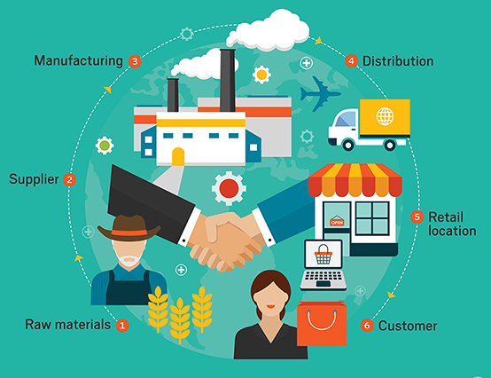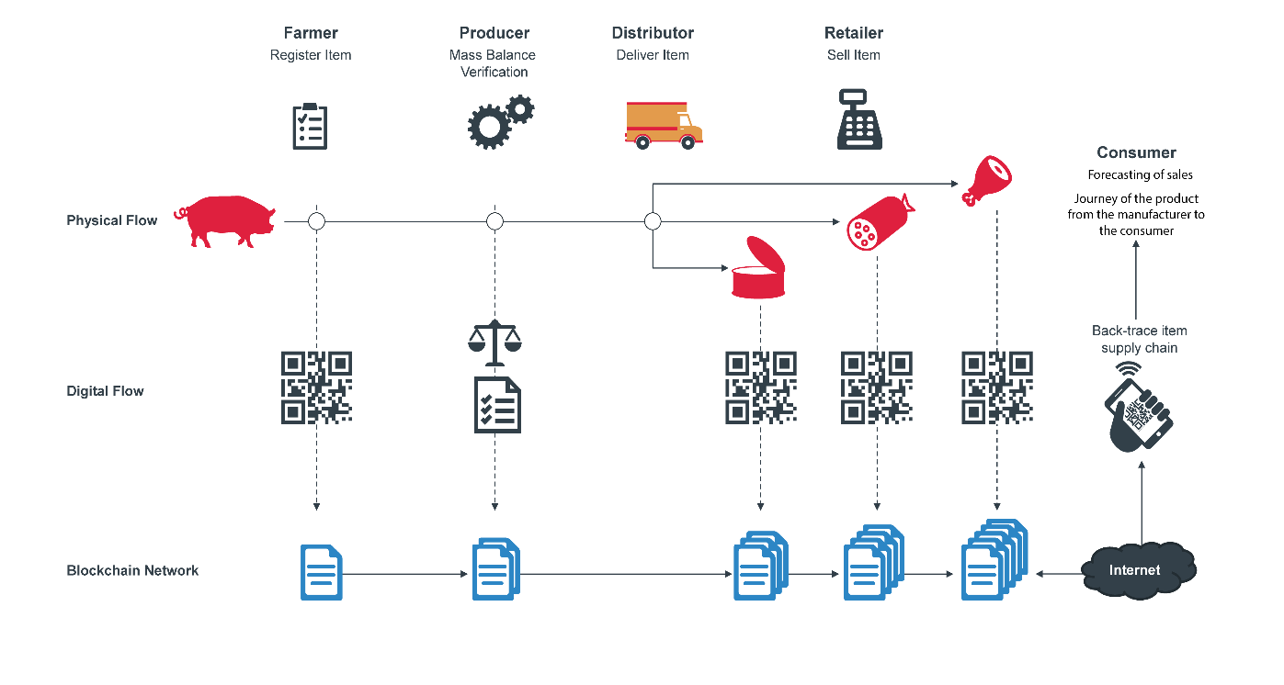

Objectives (1 main objective and 4 sub objectives):

**Main Objective -** To find fresh and organic food products with ease by ensuring that all steps from food production to delivering it to the customer are transparent and reliable.

(blockchain Technique is use to Provide reliability and integrity in the supply chain for the Consumer. Records on the blockchain cannot be erased which is important for a transparent supply chain.)

**Sub Objective**

1. To encourage and help the consumer to purchase fresh and organic foods.
2. To provide product review system (Related to Freshness/price/Days) according to the comments commented by the customers.
3. To find out what products that respond to seasonal changes throughout a Year.
4. To make purchasing an enjoyable experience rather than a tedious, unexciting one.

Technologies to be used:

Block Chain Techniques

Machine Learning Techniques

Deep Learning

Image Processing Techniques

NLP

Python

React Native

Node.js

Team Members:

|  |  |
| --- | --- |
| Student Name | Student ID |
| Leader: H.D.M. Perera | IT16122956 |
| Member 2: D.K.G.S.H. Liyanage | IT16175358 |
| Member 3: D.S.M. Mallikarachchi | IT16235298 |
| Member 4: A.W.M.J.S. Bandara | IT15145994 |

**For official use only**

Acceptable: YES/NO

Changes proposed: ____________________________________________________________________________________________________________________________________________________________________________________________________________________________________________________________________________________________________________

Any other Comments: _________________________________________________________________________________________________________________________________________________________________________________________________________________________________

Approved by CDAP Group:

|  |  |
| --- | --- |
| **Member’s Name** | **Signature** |
|  |  |
|  |  |
|  |  |

**Important**:

1. According to the comments given by the panel, do the necessary modifications and get the approval by the **same panel**.
2. If the project topic is rejected, find out a new topic and inform the CDAP Group for a new topic pre-assessment.
3. A form approved by the panel must be attached to the **Project Charter Form**.